

**Neurological Conditions:**

* Autistic
* ADHD - Inattentive, Combined, Hyperactive

**Social & Emotional Conditions:**

* Severe anxiety
* PDA (Pathological Demand Avoidance/Pervasive Drive for Autonomy) profile of Autism.

**Key Features of PDA (Pathological Demand Avoidance)**

* Resisting & avoiding the ordinary demands of life
* Appearing socially ‘able’ but is likely to be masking their underlying differences & difficulties with social interactions & communication.
* Experience intense emotions and mood swings
* Intense focus on other people (real or fictional)
* An intense need for control, which is often driven by anxiety or an automatic ‘threat’ response.
* Conventional approaches in support, parenting & teaching are ineffective.

**Please know & remember - This is part of <Student Name>’s disability. This is NOT voluntary.**

* Demand avoidance in PDA is about the person’s inability to take action, complete a task etc. It’s not a matter of won’t, but rather, can’t.
* Demands of ALL types, including things one would not consider to be a demand, are seen as automatic threats & this anxiety response & feeling of panic sets in.
* Those with a PDA profile see themselves as ‘equals’ or ‘above’ authority; there is no hierarchy. As a result of this perception, power imbalances need to be avoided, & if unable to be, need to be carefully managed. This is about the person’s need for control. This is not about & doesn’t stem from an intrinsic need for power or self-serving elitism.
* <Student Name>’s PDA profile means that <he/she/they> will avoid things that he/she/they likes, that <he/she/they> wants to do & things that give <him/her/them> joy; things to <his/her/their> detriment, rather than complying with the demand. This is part of <his/her/their> disability & is not voluntary.
* <Student Name> is a capable student. There is always a ‘valid’ & ‘legitimate’ reason (according to <him/her/them>) as to why <he/she/they> are not engaging, participating, commencing or completing work & tasks. Getting to the bottom of this helps to anticipate these situations & hopefully avoid, or better manage, the next one.

**Effective Communication Strategies & Techniques**

These may seem unconventional but building a partnership based on trust, flexibility, careful use of language & balancing demands works best.

* <Student Name> will need to be **provided reasons** for the subject, the task, the topic etc. Providing reasons helps <him/her/them> to understand the purpose of things. If there is a perception or feeling that there is no point or no purpose, it will be impossible to engage <Student Name>.
* <Student Name> will benefit from **knowing what topics & what assignments are planned next**. Knowing what’s expected in terms of work, roles, expectations & timing will all work towards supporting <his/her/their> anxiety over school work.
* <Student Name> will benefit from **being advised** of important conversations, conversations that require <Student Name> to process a lot of information & conversations that require a decision or outcome prior to them occurring. Negotiating a ‘meeting time’ to discuss these things is recommended.
* It will be beneficial if <Student Name>’s teachers, & anyone <he/she/they> has contact with are able to be flexible & less directive. Phrasing & terminology plays a huge part in connecting with someone with a PDA profile.
* Allow negotiation as much as possible as this works towards building trust.
* Personalise learning – provide genuine options and choices over what work is completed, when, where, how & who with.

**PANDA -** Source: <https://www.pdasociety.org.uk/>

* P - Pick your battles
* A - Anxiety management
* N - Negotiation & collaboration
* D - Disguise & manage demands
* A - Adaption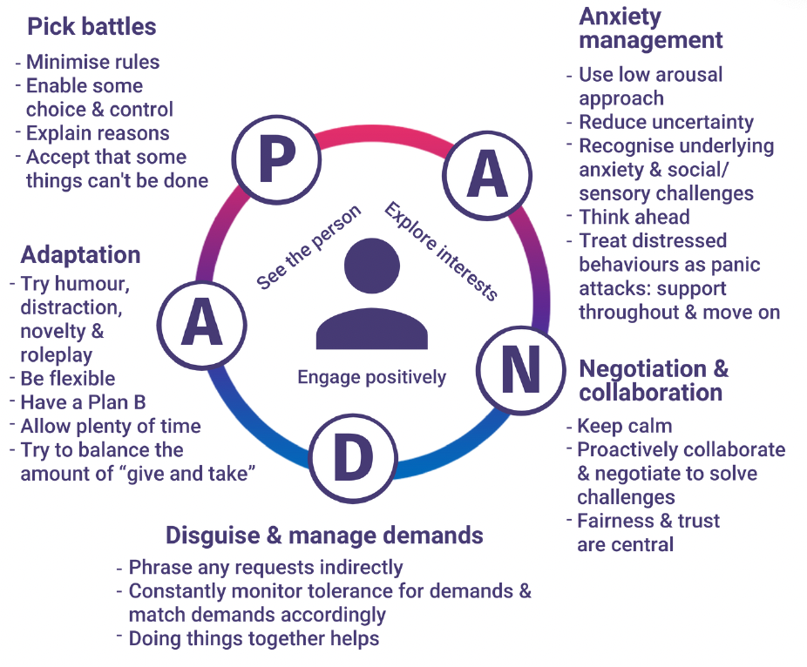

**Expectations & Considerations Around School Work & Engagement**

* **Interest-based learning** will be more effective for <Student Name> as the ‘learning’ & ‘tasks’ will be camouflaged nearly into something that interests <him/her/them>. This approach will help <Student Name> to engage with the task as the topic is of interest as well as continue to build a trusting relationship between <Student Name> & <his/her/their> teacher. Interest-based approaches may also work towards softening <his/her/their> stance towards hierarchy.
* Adopt a **child-centred approach**, focusing on <Student Name>’s needs and strengths.
* **Be led by <Student Name>** – PDA students need to see a meaningful purpose to learning & often thrive when able to follow what they’re passionate/inquisitive about or when something becomes relevant/useful to their lives.
* Recognise & understand that any outward behaviour, shutdown, refusal etc will be underpinned by emotional, social & sensory overload. <Student Name> is not being ‘oppositional’ or ‘defiant’ for social acceptance &/social credits. <His/Her/Their> **conduct is a response to being distressed &/or overwhelmed & a genuine response to <his/her/their> anxiety.**
  + <His/Her/Their> conduct does not give <him/her/them> joy.
  + <His/Her/Their> conduct, which is a response to being extremely distressed, must not be punished. (UNLESS it’s an issue of safety or clearly goes against the school’s code of conduct. Please notify parents prior to any conversations or measures to discipline any breaches).
* Focus needs to be on developing & building a trusting relationship with <Student Name>, prior to any learning or attempt of work.
* We all have the same expectations of school, learning, engagement, participation & task completion. With <Student Name>, an understanding that a trusted relationship takes time & patience needs to take precedence over everything.
* Work with us, the family, as we are all on the same page.
* Be willing to challenge & adjust your own mindset & keep doing this.
* Let go of some of your expectations when it comes to recognising & recording progress that’s conventional.

**Working Collaboratively**

* The school, teachers & parents, ultimately have the same goal & want the same thing, so working collaboratively is essential.
  + Share the techniques & strategies that have been successful with each other.
* We know this is unconventional, but we know this is what <Student Name> needs.
* Let’s focus on the end goal rather than the means of getting there.
* In the event that <Student Name> displays negative, disrespectful or concerning behaviours, we are notified so we can assist in identifying the triggers & supporting <Student Name>, the school & <his/her/their> teachers through this situation.
  + We would like these situations to be teachable moments & opportunities for progress & not become barriers to future learning & engagement with <him/her/their> teachers.